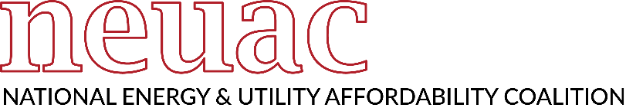
An Open Letter to Congressional Appropriations Committees
In Support of the Low Income Home Energy Assistance Program (LIHEAP)
Dear House and Senate Appropriators:
The Low-Income Home Energy Assistance Program (LIHEAP) is a critical, life-saving program that targets and serves the most vulnerable households, including older Americans, individuals with disabilities, and families with young children.

Many LIHEAP-eligible households subsist on fixed incomes, meaning that their pay does not increase when the cost of heating and cooling their homes increases. Living at the lowest levels of poverty, LIHEAP recipients make heartbreaking choices every day between food, medicine, or utilities.

Only about 16 percent of eligible households are able to be served with regular LIHEAP funding. As prices increase disproportionate to wages and weather-related disasters become more prolific, funding for LIHEAP has become increasingly strained. Appropriations must take into account the need for additional resources to expand cooling programs and address the effects of extreme temperatures and commodity price increases on household budgets.
The National Energy and Utility Affordability Coalition (NEUAC), along with our dedicated partners signing this letter, strongly urge Congress to maximize funding for LIHEAP in FY 2024 in order to prevent a catastrophic lack of energy access across the country as families struggle with kitchen table budgets that are increasingly difficult to balance.
Energy is essential to provide heating and cooling, hot water, and refrigeration. For more than 40 years, LIHEAP has reliably and effectively stabilized families and provided consistent benefits that relieve the energy burden for those most vulnerable to unsafe indoor air temperatures. This premier federal energy assistance program also keeps electricity flowing to life-saving equipment for those with chronic health conditions, including respiratory conditions like COVID-19. LIHEAP prevents disconnection of service, contributes to housing and family stability, and preserves the dignity of those served by helping them pay their bills in full and on time.
According to U.S. Census data, nearly 64 million people survive below 150 percent of the Federal Poverty Level. Elders, young children, and those with disabilities are most susceptible to extreme temperatures and are prioritized by LIHEAP. In FY 2020, nearly 72% of LIHEAP recipient households included one or more vulnerable persons.
There is a clear need to expand resources to support those who have fallen behind because of increased energy burden and extenuating circumstances, to protect those with fixed or limited incomes, and assist those living with economic hardship. NEUAC and its national coalition of more than 250 member organizations, along with [number of signers to be added upon sending] stakeholder organizations across the country that have signed this letter, urge Congress to defend LIHEAP and maximize funding appropriations in FY 2024.
Thank you for your consideration.

https://neuac.org/wp-content/uploads/2021/04/US-state-sheet-2022.pdf
https://www2.census.gov/programs-surveys/cps/tables/pov-01/2022/pov01_150_1.xlsx
https://neuac.org/wp-content/uploads/2021/04/US-state-sheet-2022.pdf
https://neuac.org/membership/our-membership/

