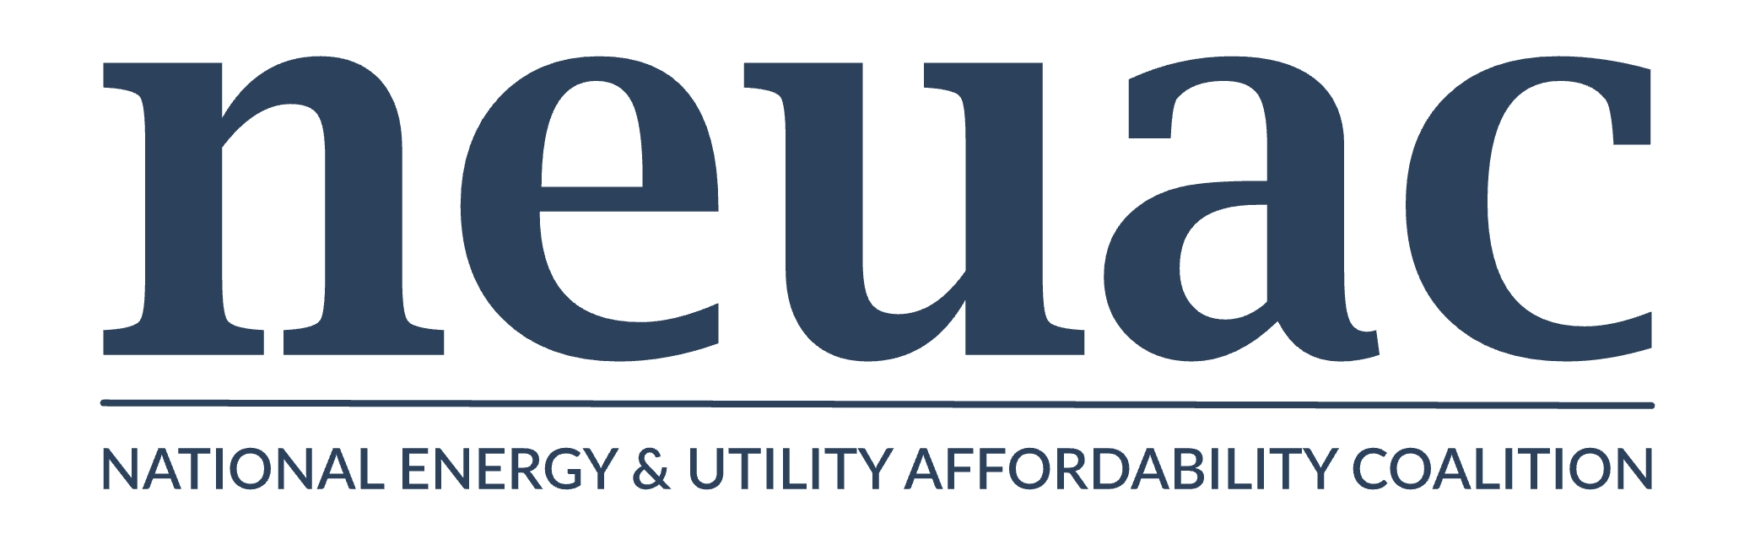

Pre-written editorial letter for submission to your local media outlet on LIHEAP Action Month

Opinion letters to newspapers are generally submitted online. Go to the online version of your local or regional newspaper and search “letters to the editor.” The instructions, with an email address, should come up.

Below is a short letter you can submit. Customize for your state and use data from the NEUAC state LIHEAP sheet for your state or states.

Dear Editor,

During the most extreme weather periods, energy is a life-critical resource. Unfortunately, many (insert your state moniker) families continue to struggle with energy affordability, in some cases putting their lives at risk or forcing people to make choices between things like medicine or food or paying their utility bills. The Low Income Home Energy Assistance Program (LIHEAP) provides help to vulnerable (insert your state moniker) by assisting with energy costs for those most vulnerable in our community.

[insert personal story from a LIHEAP recipient in your community, if available]

LIHEAP protects families across the country and in [your community] from dangerous indoor air temperatures, like it helped [name of client in story above].

Unlike entitlement programs that receive increases with growth in the eligible population, LIHEAP does not automatically receive an increase and must be reviewed and approved by Congress annually.

LIHEAP advocates are asking Congress to protect and improve the funding for the program to continue to offer this critical assistance. LIHEAP is a small Federal program, but it has a multiplier effect. When struggling families can afford energy, they are more likely to remain in their homes, households are stabilized, and seniors and veterans maintain access to service.

Call (XXX-XXX-XXXX) if you or someone you know needs energy assistance, and thank you for your support for LIHEAP!

Name, Title

Organization

Address

Phone

Email